**S.V.G.M. GOVERNMENT DEGREE COLLEGE**

**KALYANDURG**

 **NAAC with ‘B’ Grade**





**Coaching for**

**Competitive Exams**

**&**

**P.G Entrance**

**2019-2020**

**Circular**

Date: 27-01-2020

To: All Students

Subject: Free Competitive Examinations Training Program

With the kind permission of Dr. D. Jayarama Reddy, Principal of SVGM Govt. Degree College, Kalyandurg, we are pleased to announce that Sri T. Venkata Ramana, Lecturer in Commerce, will be conducting a Free Competitive Examinations Training Program.

Program Details:

Duration: 30 days

Commencement Date: 29 January 2020

Training Includes:

PG M.Com and other Competitive exams related with Accountancy Subject Example Junior Accounts Officer.

Entrance Preparation (30 days): Comprehensive coaching covering essential topics such as Financial Accounting, Business Organization & Management, Cost & Management, Business Economics and Income Tax.

For: PG M.Com Entrance Preparation (30 days)

Registration:

Interested students are requested to register for the Free Competitive Examinations Training Program at the Commerce Department.

Sd/-

T. Venkata Ramana,

Lecturer in Commerce

SVGM Govt. Degree College, Kalyandurg

**Summary Report:**

**Free Competitive Examinations Training Program**

With the gracious permission of Dr. D. Jayarama Reddy, Principal of SVGM Govt. Degree College, Kalyandurg, Sri T. Venkata Ramana, Lecturer in Commerce spearheaded a commendable initiative to provide free Competitive Examinations training to students. The program commenced on 29th January 2020 and spanned a duration of 30 days.

**Overview:**

The Free Competitive Examinations Training Program catered to the diverse needs of students preparing for a multitude of competitive exams, including PG M.Com Entrance and Other Competitive Exams related with Accounting. Under the expert guidance of Sri T. Venkata Ramana, U. Eswar Reddy and B.K.Ganesh Rao participants received comprehensive coaching and support to enhance their preparation.

**Training Highlights:**

**PG Computer Science Entrance Preparation (30 days):** The program offered rigorous coaching covering essential subjects such as Financial Accounting, Business Organization & Management, Cost & Management, Business Economics, Income Tax and fundamentals of Computers.

**Mock Exam:**

As a pivotal component of the training program, a mock exam was conducted on 6th March 2020, replicating the format and conditions of PG M. Com Entrance exams. This mock exam provided participants with an invaluable opportunity to assess their preparedness and refine their strategies for the actual examinations.

**Conclusion:**

The Free Competitive Examinations Training Program, conducted under the leadership of Sri T. Venkata Ramana, has made a significant impact on the preparation and confidence levels of students aspiring to Commerce Subjects in competitive exams. Through dedicated coaching, expert guidance, and rigorous mock tests, participants have been empowered to pursue their academic and career aspirations with confidence.

Sincerely,

T. Venkata Ramana,

Lecturer in Commerce,

SVGM Govt. Degree College, Kalyandurg.

**2019-20**

**Model PG Entrance Exam**

**Department of Commerce,**

**SVGM Govt. Degree College, Kalyandurg**

**Multiple Choice Questions Answer all the Questions 25 x 1 = 25**

**Section – A: Financial Accounting**

**1.** What type of account is "Accumulated Depreciation"?

a. Asset account b. Liability account

c. Contra asset account d. Equity account

**2.** Which financial statement reports the changes in equity during a specific period?

a. Income statement b. Statement of cash flows

c. Statement of retained earnings d. Balance sheet

**3.** What is the purpose of adjusting entries in accounting?

a. To correct errors b. To record transactions that span multiple periods

c. To update accounts for accruals and deferrals d. All of the above

**4.** Which accounting method records revenues and expenses when they are earned or incurred, regardless of when cash is received or paid?

a. Cash basis accounting b. Accrual basis accounting

c. LIFO method d. FIFO method

**5.** What is the purpose of the Statement of Cash Flows?

a. To report a company's financial position

b. To provide details about changes in equity

c. To show how cash is generated and used during a specific period

d. To disclose contingent liabilities

**Section – B: Business organization & Management**

**6.** The Hawthorne studies are associated with which management theory?

a. Classical management theory b. Human relations theory

c. Scientific management theory d. Contingency management theory

**7.** What is the purpose of a mission statement in an organization?

a. To outline the company's financial goals

b. To communicate the organization's purpose and values

c. To establish the company's chain of command

d. To define the organization's product line

**8.** Which of the following is an example of an extrinsic motivator?

a. Job satisfaction b. Recognition

c. Salary increase d. Sense of accomplishment

**9.** What is the purpose of the PESTLE analysis in strategic management?

a. To evaluate internal strengths and weaknesses

b. To assess the competitive landscape

c. To analyze the external macro-environmental factors

d. To identify potential customers

**10.** Which stage of the decision-making process involves evaluating the effectiveness of the chosen solution?

a. Implementation b. Identification c. Evaluation d. Selection

**Section – C: Income Tax**

**11.** What is the purpose of Form 1099-MISC?

a. To report income from employment b. To report interest income

c. To report income from self-employment or freelance work

d. To report interest income

**12.** What is the filing status for a taxpayer who is unmarried and has no dependents?

a. Single b. Head of Household

c. Married Filing Jointly d. Ualifying Widow(er)

**13.** What is the standard deduction for a married couple filing jointly in the United States for the tax year 2023?

a. $12,950 b. $18,800 c. $24,800 d. $32,500

**14.** What is the purpose of Form 1040X?

a. To request an extension for filing taxes

b. To amend a previously filed tax return

c. To report income from self-employment.

d. To claim additional tax credits

**15.** Which of the following is a non-taxable source of income?

a. Salary from employment b. Dividend income

c. Social Security benefits d. Rental income

**Section – D: Fundamentals of Computers**

**16.** What does GUI stand for?

a. General User Interface b. Graphic User Interface

c. General Understanding of Interfaces d. Global User Integration

**17.** What is the purpose of a cache memory?

a. Store frequently used programs and data for quick access

b. Store permanent data c. Control input devices

d. Execute arithmetic and logical operations

**18.** What does the acronym URL stand for?

a. Uniform Resource Locator b. Universal Remote Locator

c. Unified Resource Link d. User-Related Link

**19.** Which of the following is an example of an input device?

a. Printer b. Monitor c. Keyboard d. Speaker

**20.** What does HTML stand for in the context of web development?

a. Hyper-Text Markup Language b. High-level Text Management Language

c. Hyperlink and Text Manipulation Language

d. High-performance Text Modeling Language

**Section – E: Cost & Management Accounting**

**21.** Which method allocates indirect costs based on the actual usage of resources?

a. Activity-Based Costing (ABC) b. Traditional costing

c. Direct costing d. Variable costing

**22.** What is the purpose of a cost allocation base in cost accounting?

a. To calculate fixed costs b. To allocate indirect costs to cost objects

c. To determine variable costs d. To calculate contribution margin

**23.** Which costing method is most suitable for decision-making and short-term planning?

a. Absorption costing b. Variable costing

c. Job costing d. Process costing

**24.** What is the formula for calculating the predetermined overhead rate?

a. Estimated Overhead Costs / Estimated Activity Level

b. Actual Overhead Costs / Actual Activity Level

c. Actual Activity Level / Estimated Overhead Costs

d. Estimated Activity Level / Actual Overhead Costs

**25.** What is the purpose of a cost variance analysis?

a. To identify areas of cost overruns b. To calculate total costs

c. To determine selling prices d. To allocate fixed costs

**Photo Evidences**:

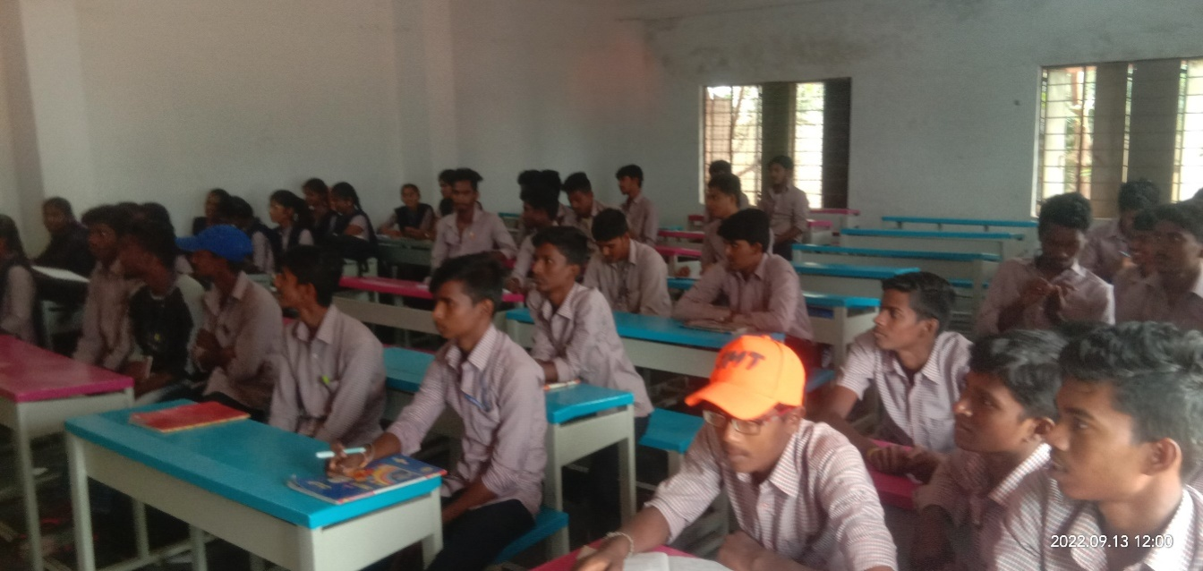

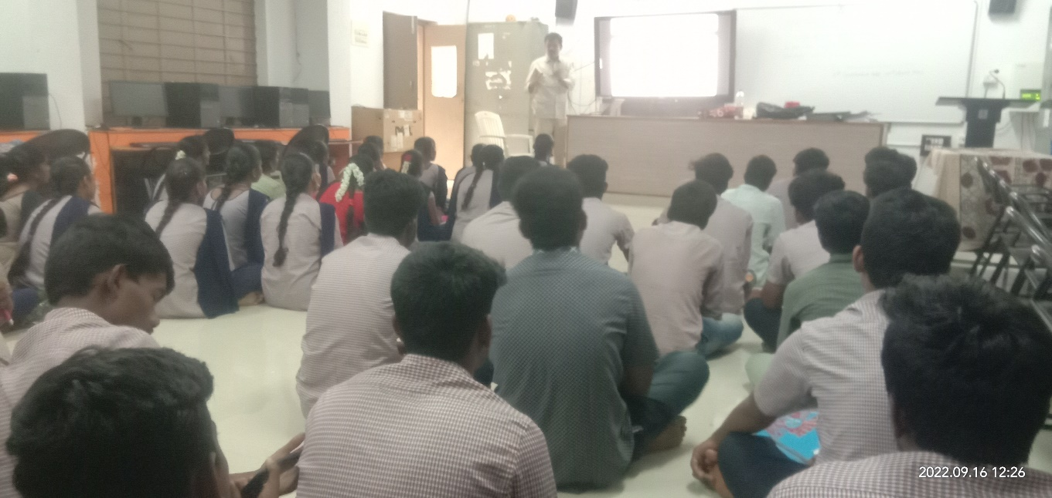

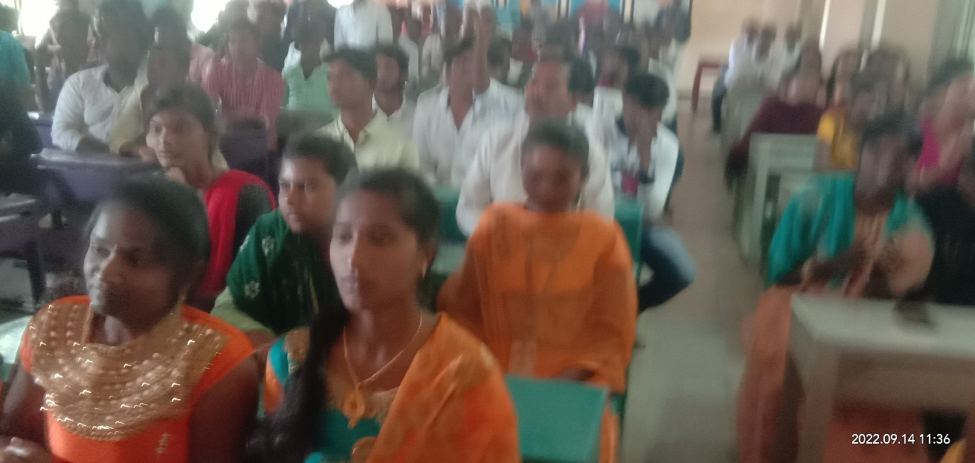

Photos for Evidence

